**Flop ratio = 1613/14876 = 10.84% (visit: Item number 16)**

1. Opened the flow.tcl in vim

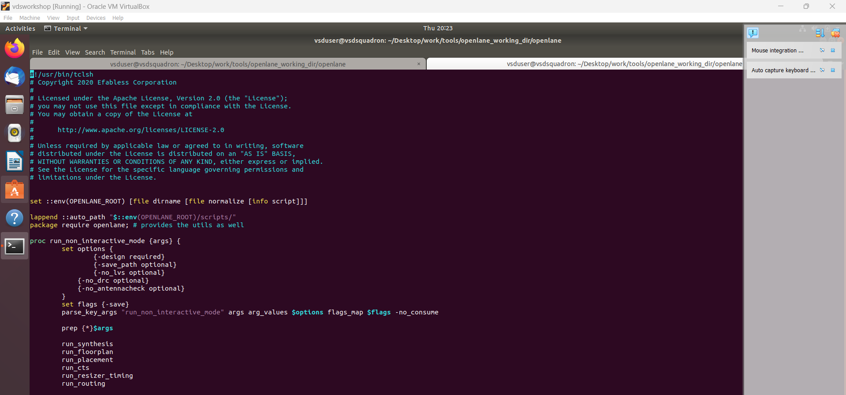

1. Opened the working folder & opened the tech file & checked in vim

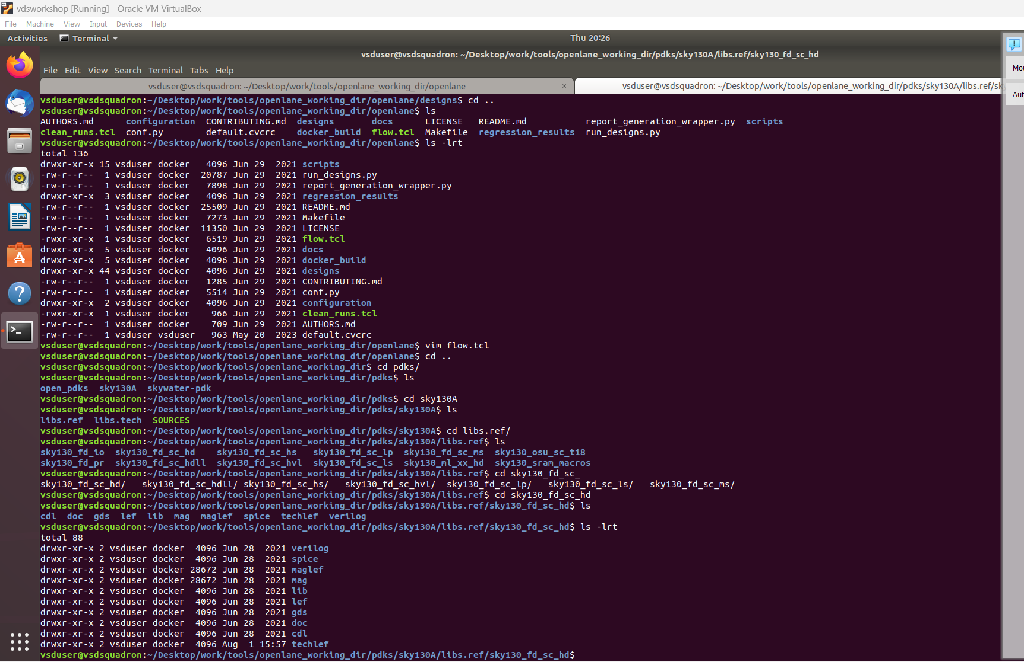

1. Ran the commands below in with docker in the working directory

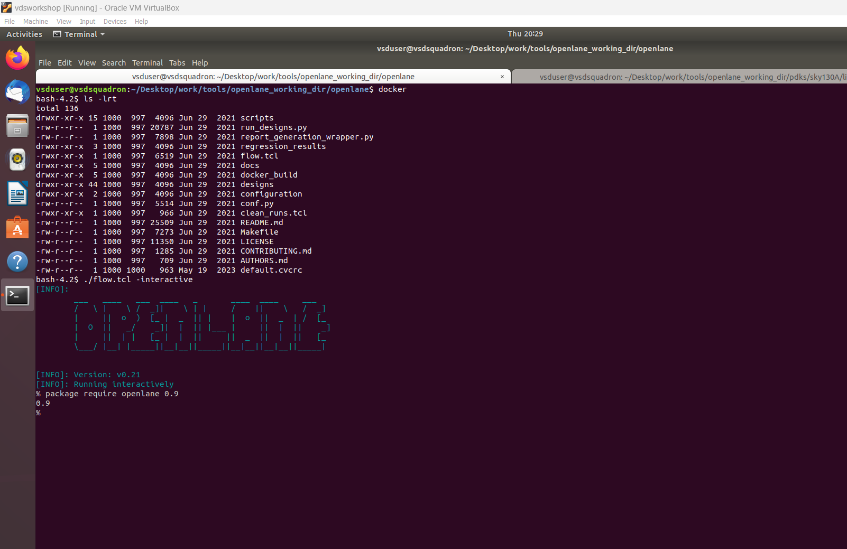

1. Opened the working directory designs

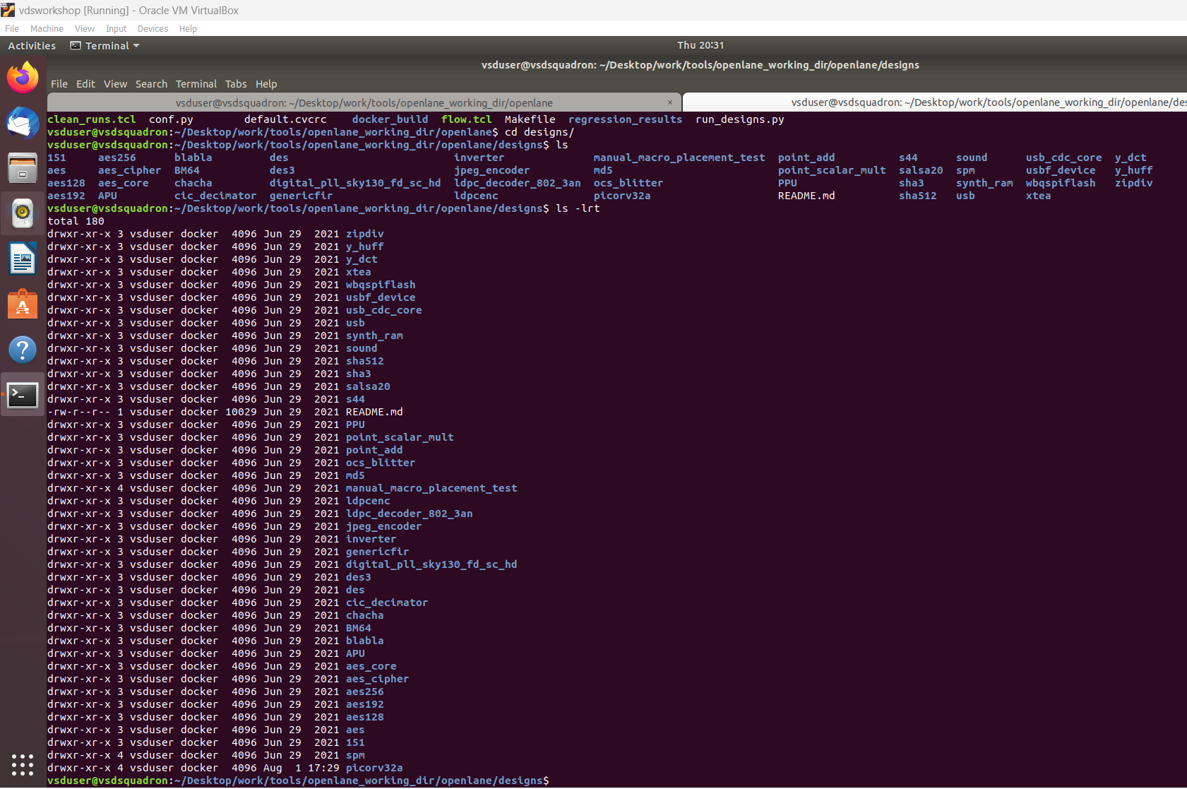

1. Opened the config.tcl in vim & checked the period other items

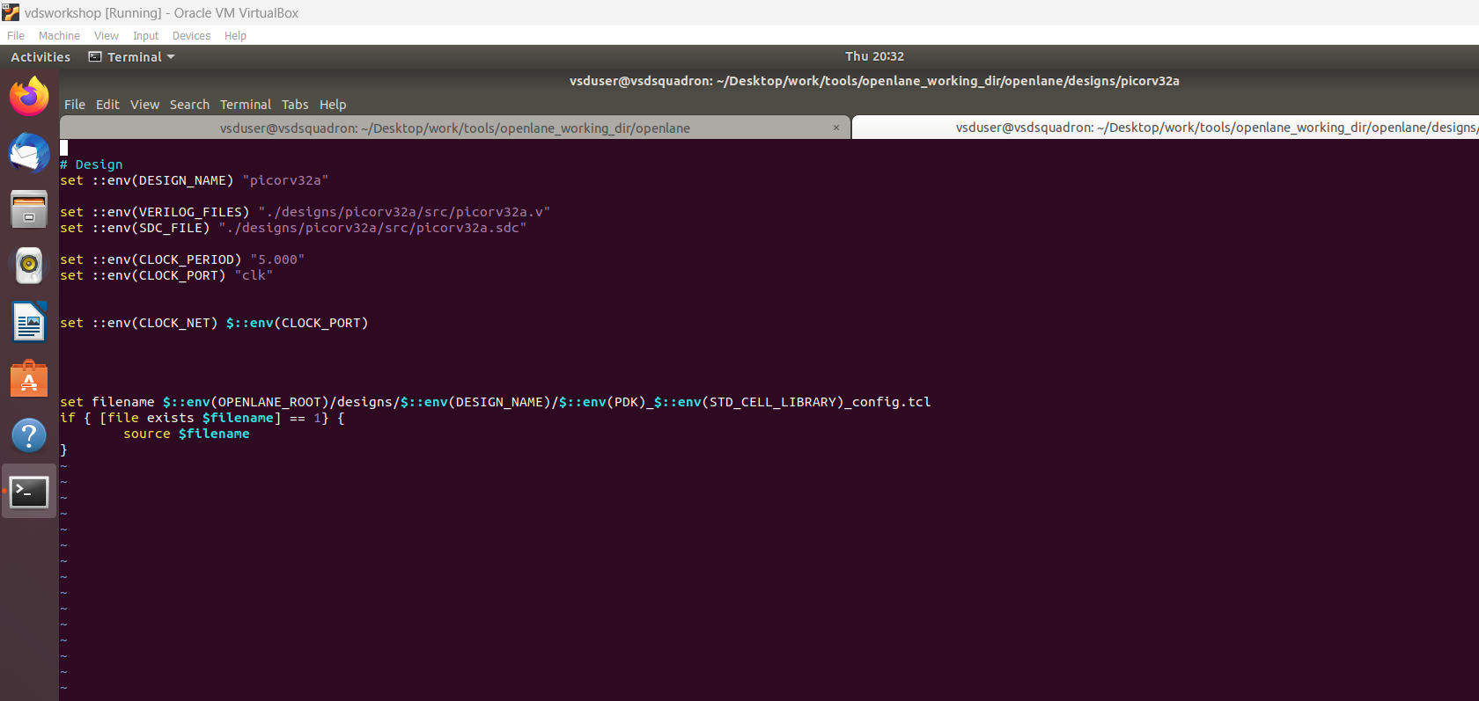

1. Opened the sky130A_sky130_fd_sc_hd_config.tcl file & checked the period other items

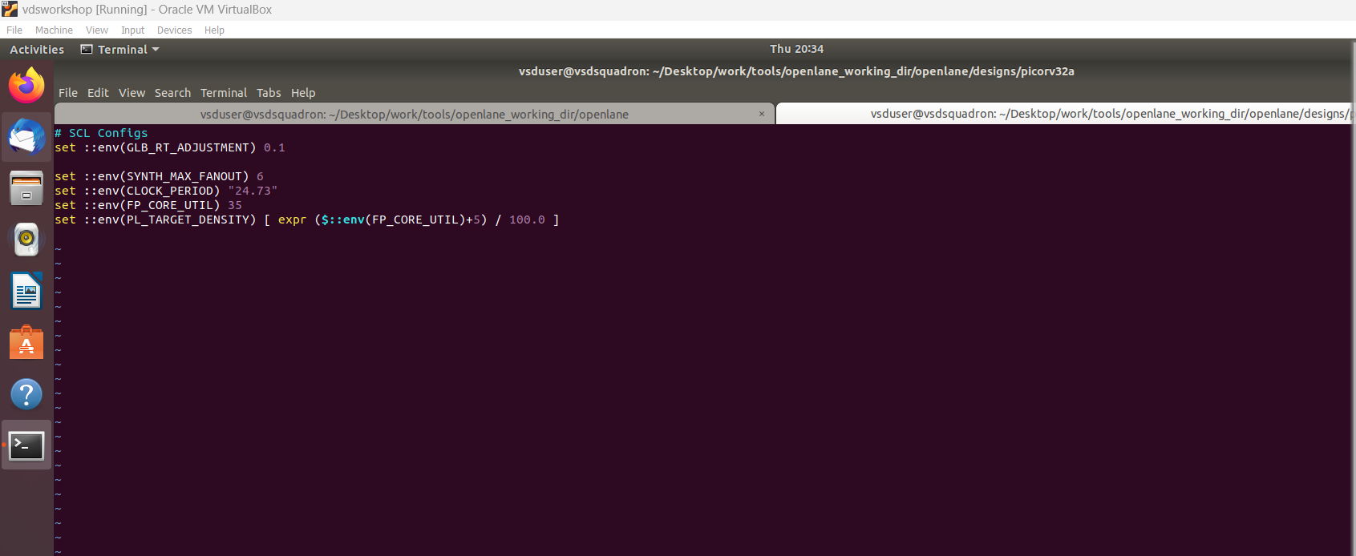

1. Ran the command prep -design picorv32a & found that the run folder is created in the picorv32a design folder

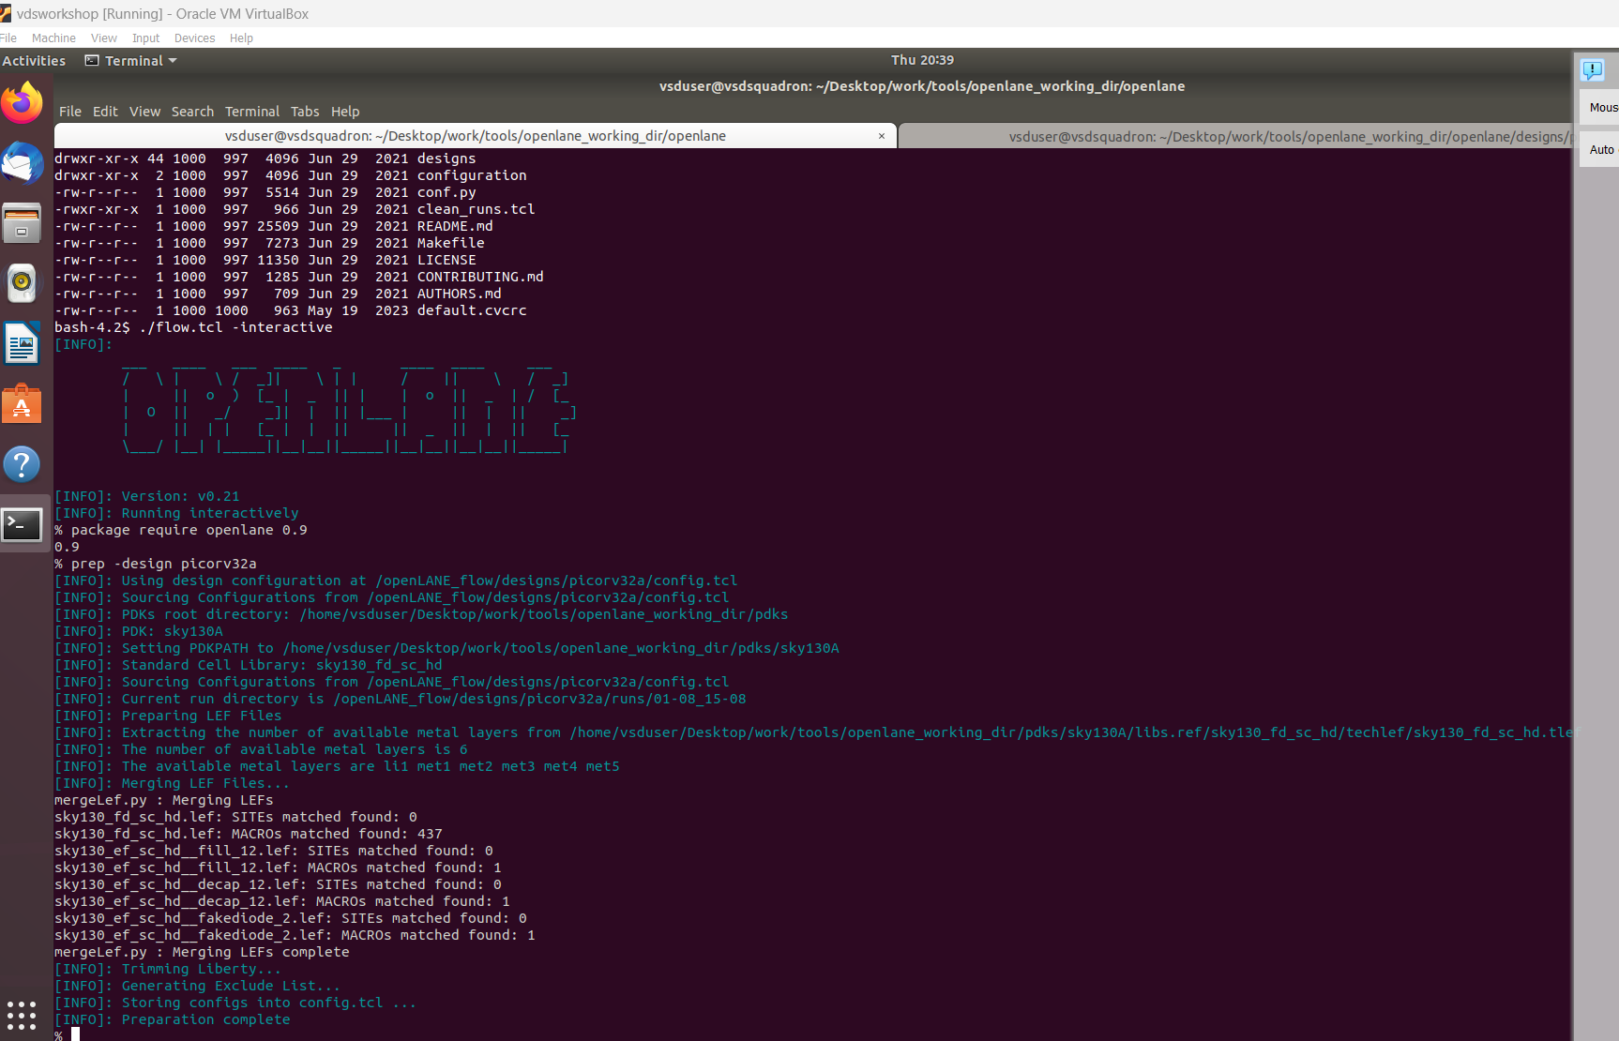

1. Went to the design folder and did ls -lrt to check the folders created.

1. Opened the merged.lef file in vim & checked the via & metal information in the file

1. Opened the config.tcl inside runs folder for today’s run in vim

1. Checked the CORE_UTIL parameter which is 35%

1. Checked the cmd.log file

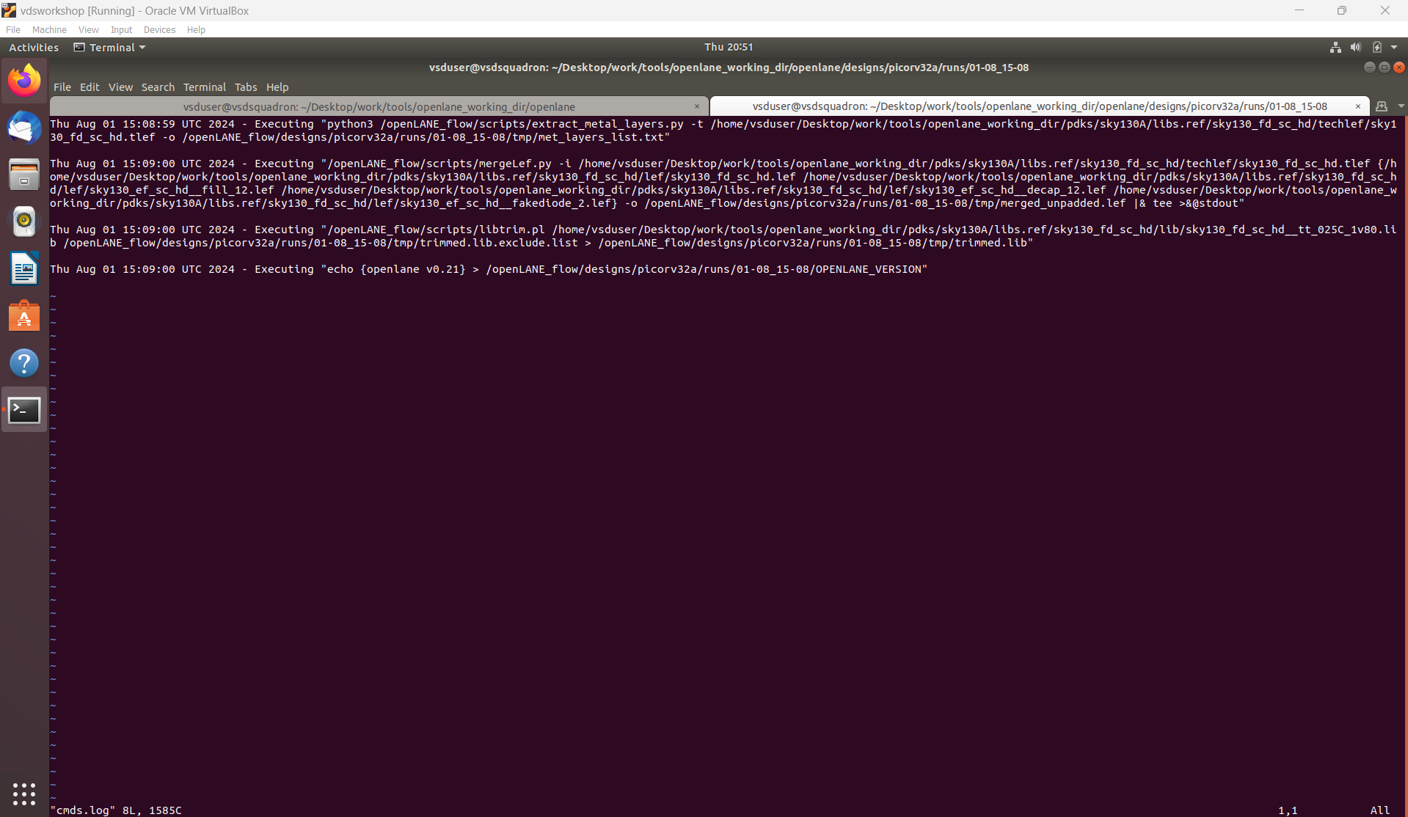

1. Ran the run_synthesis in the command line

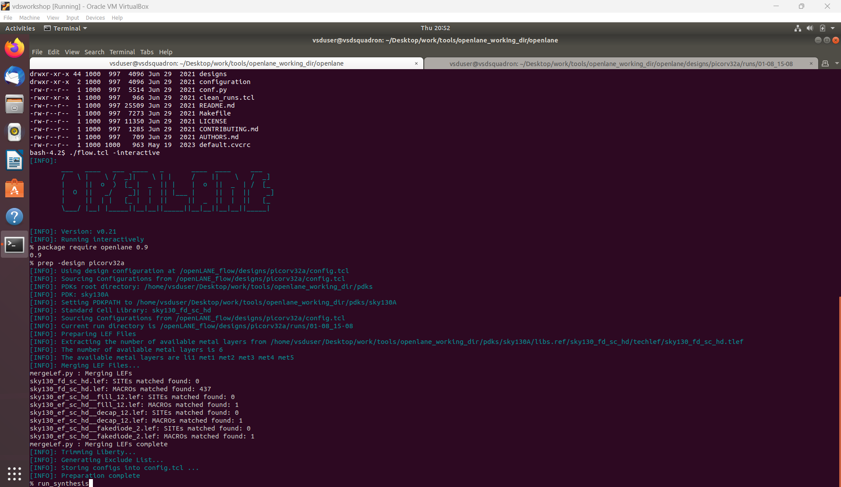

1. Went & checked the openlane website & the youtube video links mentioned in the video lecture

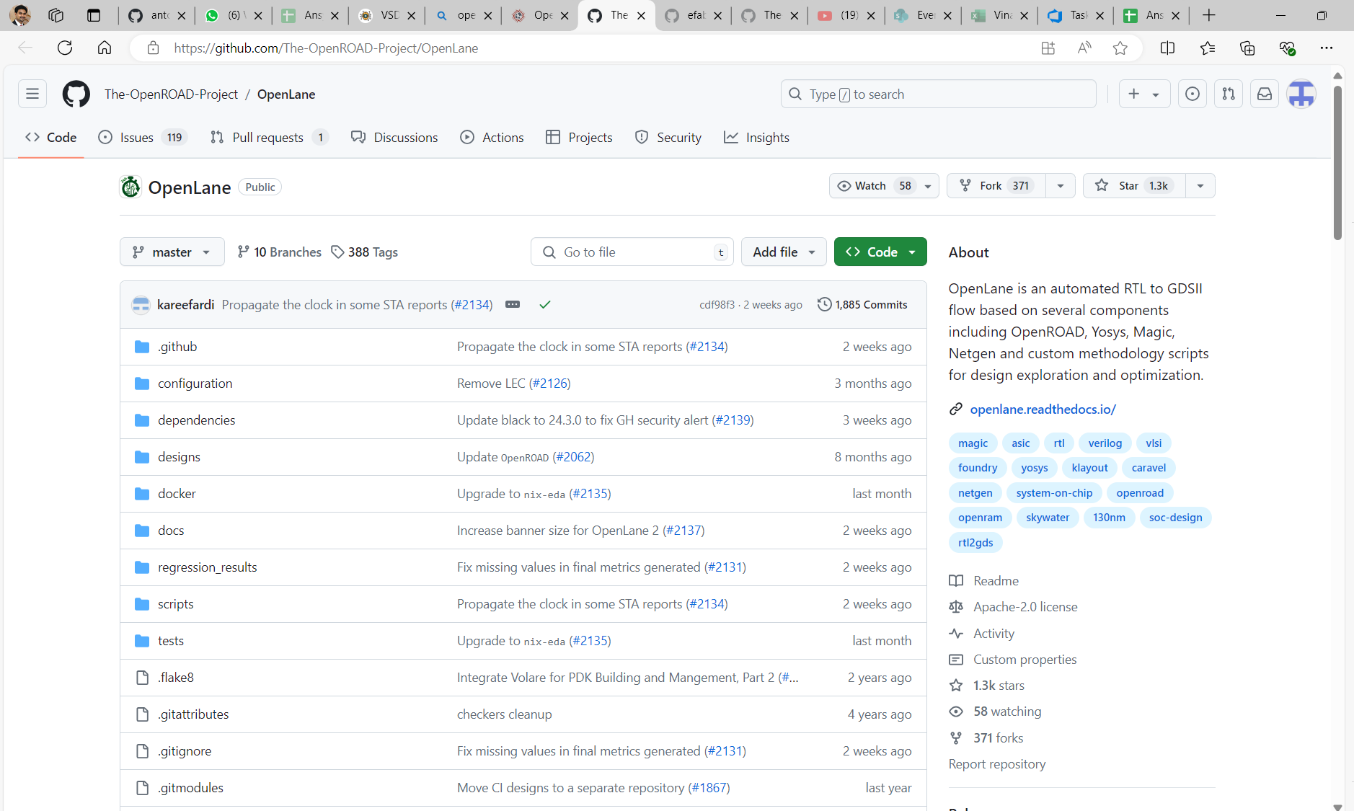

1. Checked the synthesis & found that is completed successfully

1. Opened the stat file in the report folder to find out the flop ratio

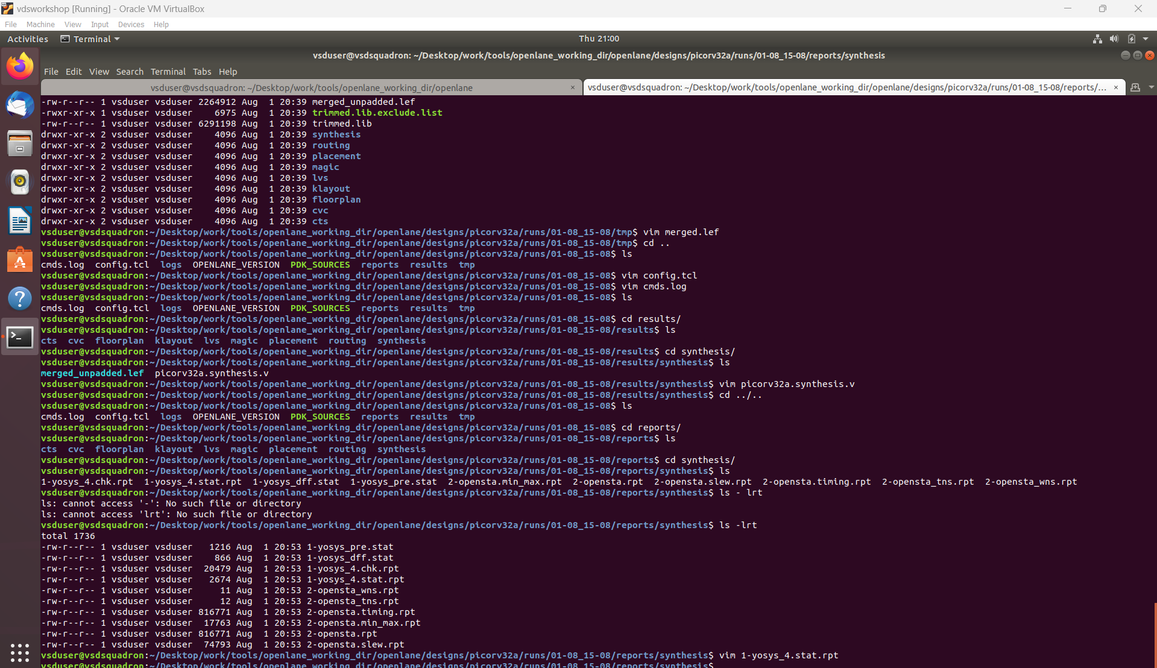

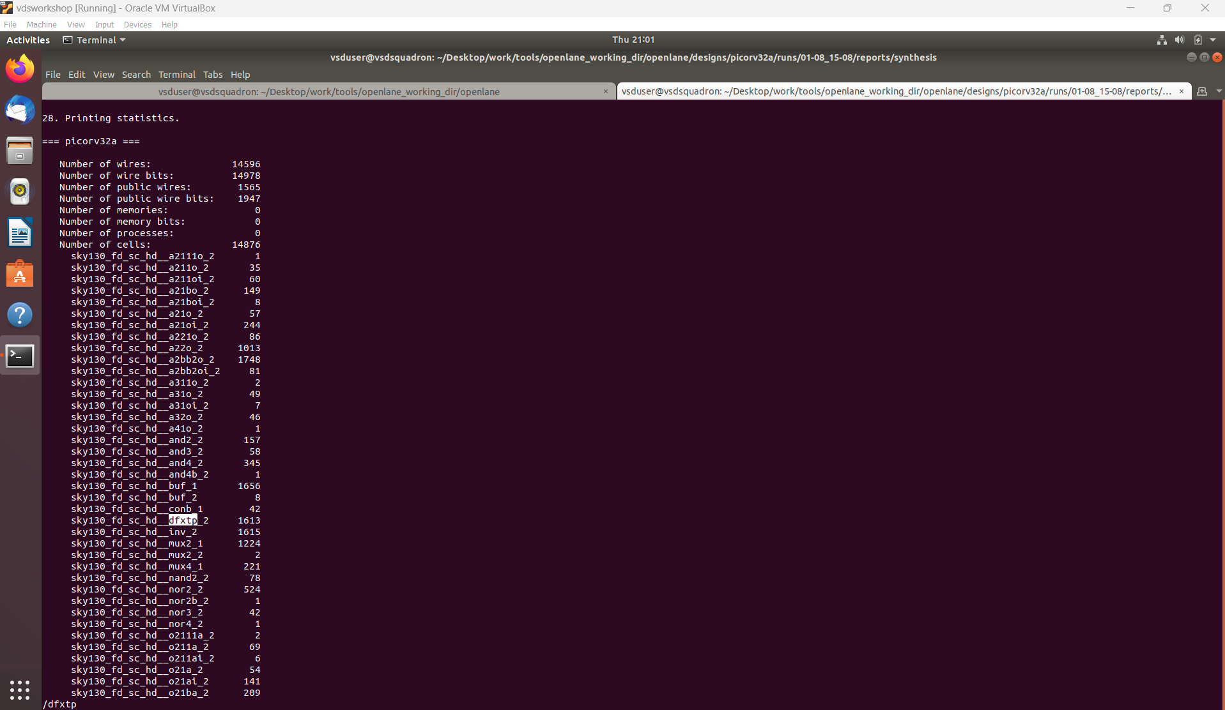

**Flop ratio = 1613/14876 = 10.84%**

1. Opened the timing file checked it in vim

